Year 2 Snow Day 2
Today snow day will focus on English, Maths and Science.
English learning
Write a description of what you can see outside on a snowy day
Write an acrostic poem using the word SNOWBALL
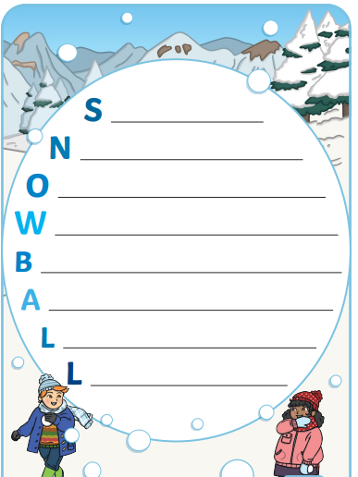

Maths Learning
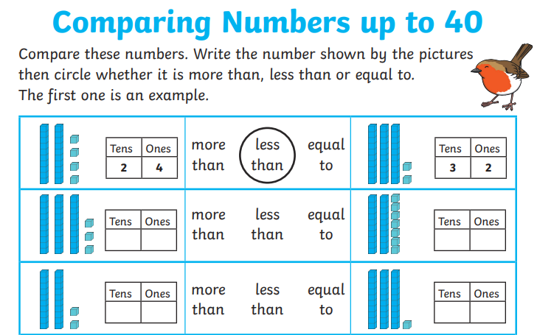
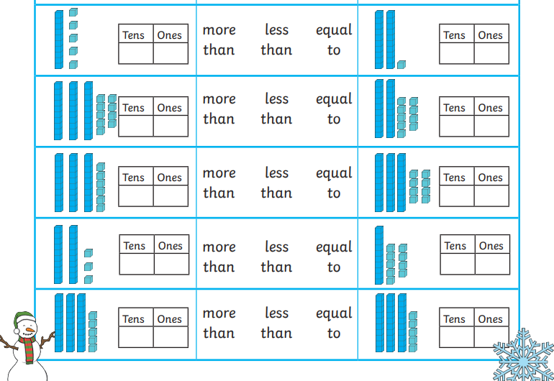

Science Learning
Ice experiment –
- Take some snow from outside or ice cubes from the freezer.
- Place a cube of ice in 4 different bowls.
- Put them in 4 different places around the house.
- Predict which cube of ice will melt the quickest.
- Predict which cube of ice will melt the slowest.
- Draw what happened.


